ISE 2204

Group Technical Report

Team Members:

Alex Pavasko

Kuan Wu

Leonardo Calizaya

**Executive Summary:**

*Let Sleeping Dogs Lie Dog Beds* is a leading provider of dog cages in the New River Valley region. Taking all the costs, including delivery fee, inventory costs and revenue of crate selling into account, the goal of maximizing the total expected profit and boosting customer satisfaction is shown from the data analyzation.

Data showing that the penalty caused from customers unable to buy crates from the store due to inventory shortages should be considered in the process of profit maximization. By taking into consideration the potential negative impact that could be caused by unsatisfied customers, results show that all scenarios do not remain at the same trend at different scales. Furthermore, the profit from average weekly sales among all scenarios decreases between those with the penalty or without the penalty. In the end, Scenario 2 shows the most profit among all other scenarios, with or without considering customer penalty.

Consequently, we recommend taking customer penalty into consideration based on the model of Scenario 2. Scenario 2 not only has greater profits compared to other scenarios, but also has a low customer dissatisfaction, and a moderate rate of shortage. Overall, it is the best option.

**Introduction:**

*Let Sleeping Dogs Lie Dog Beds* is the leading provider of dog crates in the New River Valley. Inventory is an important aspect of the company’s profit, which depends on inventory space, delivery costs, and lost sales.

The company is asking for an inventory policy controlled by an (s,S) rule with 0<s<S, where s is the number of crates available at which the company will call their regional supplier to bring the overall inventory to S at the start of the Monday morning. This is checked each Friday. Their current policy uses (5,10).

Premium XL crates sell for $200 each.The supplier charges a fixed delivery fee of $300, and a variable fee of $50 per item. Additional costs of the store are estimated to be $10 per unit at the end of each week. A probability chart indicating the probability of number of crates bought is also provided. Each customer that turns away because of no crates available is estimated to cause $50 harm. The objective is to maximize the total expected profit and recommend values for s and S. Specifically, the company is also asking for the long-run average number of sales per week, fraction of lost demand, order cost, inventory holding cost, weekly profit; and the long run fraction of weeks in which an order is placed, fraction of weeks in which a shortage occurs, and fraction of lost demand.

**Results:**

The scenario that maximizes long-run weekly average profit, both with and without the lost order penalty, is when s = 3 and S = 10 (scenario 2). Changing to scenario 2 from the current inventory policy of (5,10) would result in both an increase in weekly profit and a decrease in weekly costs. Additionally, scenario 2 has the third-lowest weekly order cost, and a slightly above-average weekly inventory cost. The graph for the top 5 average weekly profits without penalty has a higher standard deviation, while in the graph including lost sales penalty we get a more reliable and smoother graph. 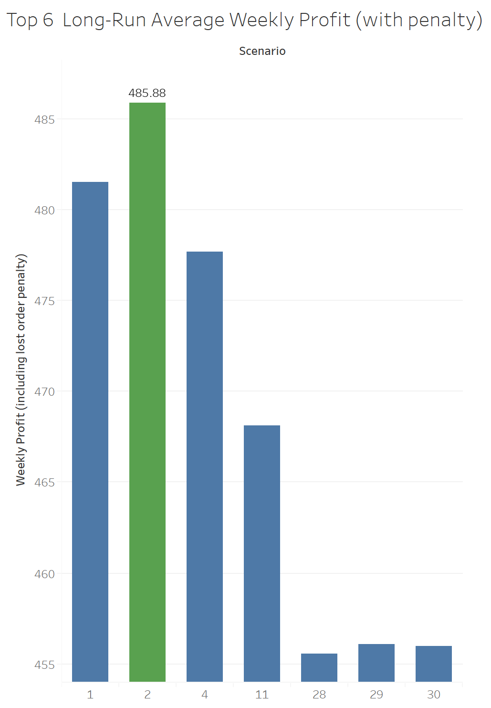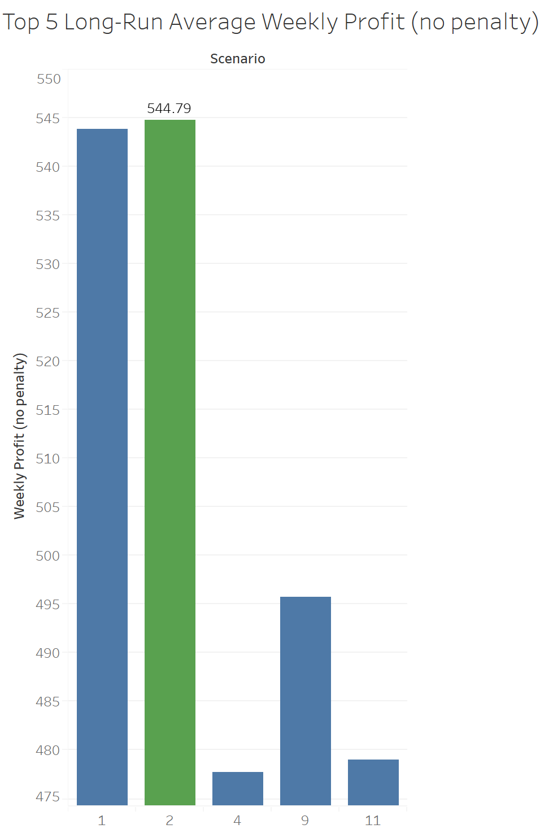

The graph with the penalty correlates better to reality because it takes scenarios with high probability to have a dissatisfied customer into account, which would lose sales in the long-run.

Scenario 11 is an example where average weekly profit decreases more compared to other scenarios when the penalty is included. Note that the graphs are displayed with different ranges to account for whether or not the penalty is in place. In both cases, Scenario 2 has the maximum average weekly profit.

Moreover, we can compare data from Scenario 2 to the average of the top 4 scenarios with higher weekly profit (including penalty). This is clearly displayed in the following graphs.

**Scenario 2: Long-Run Averages (values rounded to 2 decimals)**

|  |  |  |  |
| --- | --- | --- | --- |
| **Long-Run Averages # sold per week** | 4.81 ≈ 5 XL crates | **Long-Run Averages Fraction of Weeks that a Shortage Occurs** | 0.22286  **22.29%** |
| **Long-Run Averages Fraction of Customers who are Unsatisfied** | 0.05162  **(5.16%**) | **Long-Run Averages Fraction of Weeks that an Order is Placed** | 0.4988  **49.88%** |
| **Long-Run Averages Weekly Inventory Cost** | $ 26.37 | **Long-Run Averages Weekly Order Cost** | $ 389.92 |
| **Long-Run Averages Weekly Profit**  **(including lost order penalty)** | $ 485.88 | **Long-Run Averages Weekly Profit**  **(no lost order penalty)** | $ 544.79 |
| **s** | 3 | **S** | 10 |

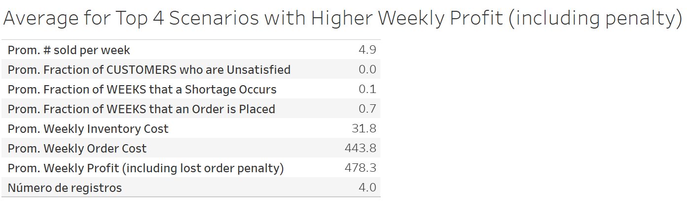

Comparing Scenario 2 to the top 4, we can see it has a 5.16% of customers who will be unsatisfied in the long-run, compared to 0% of the average. The company is currently using a cost of $50 per customer lost. However, this value is not very reliable as we can’t really measure or estimate how many crates that client would have bought in the long-run. Especially for wholesalers, this could mean a large deficit in sales. We still decided to use this data as it correlates better to reality than just saying there are no losses when a potential client is dissatisfied.

**Conclusions:**

As a result, we recommend considering the $50 lost customer penalty based on analyzing averages values of “Long-Run Averages Fraction of Customers who are Unsatisfied”, “Long-Run Weekly Profit w/o penalty”. Results show that maximizing profit, both with and without the lost customer penalty, would be best achieved using scenario 2.

Hence, the impact that it will have on the store is the additional cost while maximizing profit as well as considering the potential impact from the unsatisfied customer.

**Appendix:**

